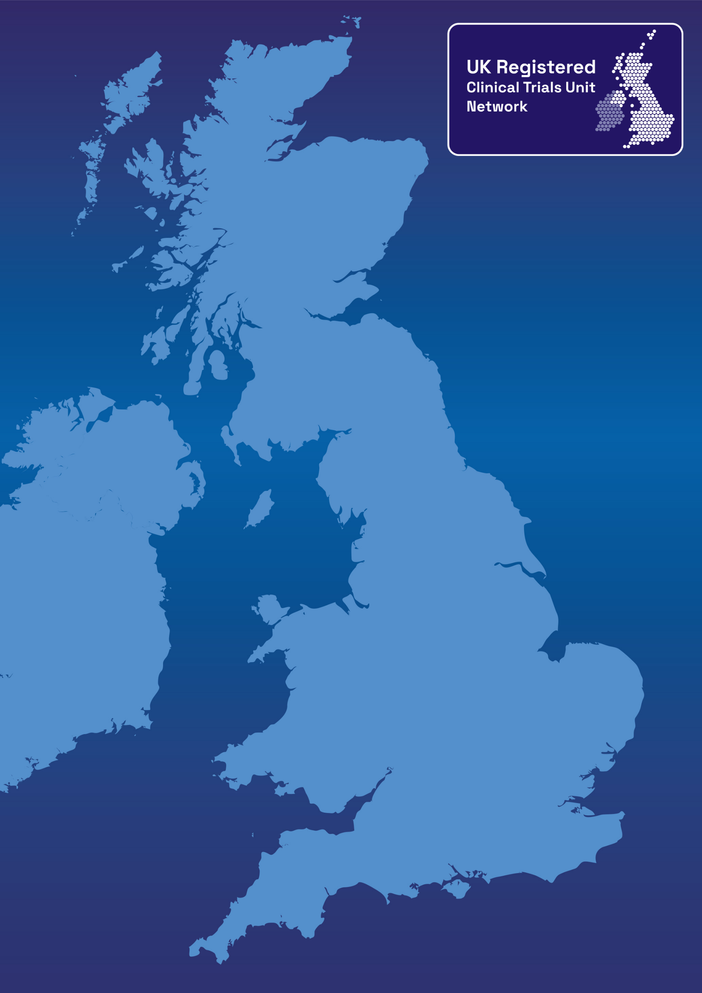
UKCRC Registered CTU Network –
Greener Monitoring Checklist
Greener Monitoring Checklist

The recommendations from the UKCRC Greener Monitoring Guidance https://ukcrc-ctu.org.uk/clinical-trial-monitoring/ are presented below as a checklist. CTUs are encouraged to complete this checklist for individual studies to help consider how the environmental impact of monitoring can be reduced.

Area | UK CRC Greener Monitoring Recommendation | How this could be applied to  [insert your study name]
Institutional level | Adhere to institutional level guidance on sustainability initiatives, relating to energy saving measures, commuting and sustainable travel.
Institutional level | Maximise use of institutional level hybrid-working policies, to enable monitoring staff to minimise unnecessary travel between monitoring visits. Promote use of public transport and incentives for using zero-emission vehicles/transport for commuting.
CTU level | Use email, video conferencing and telephone as the main means of communication between sites and monitors to avoid the use of paper and postage.
CTU level | Produce monitoring reports electronically and share via a cloud-based systems to facilitate review and response in a timely manner, removing the need for paper versions.
CTU level | Make use of the NIHR Study Support Service to help engage with sites and monitor performance (e.g. collating site level information to provide study-wide oversight).
CTU level | Consider whether field-based monitors could monitor specific geographical areas to reduce the travel time to sites.
CTU level | Work across trial portfolios to identify monitoring activities which can be carried out for more than one trial at a given site.
Trial level | Consider NIHR carbon reduction guidelines when designing new trials in particular in avoiding the collection of unnecessary data.
Trial level | Develop a robust trial risk assessment with clearly defined critical data, maximising  the use of central and remote monitoring.
Trial level | Conduct robust feasibility assessments to ensure that only sites which can deliver the trial are opened.
Trial level | Where possible electronic documents should be reviewed remotely.
Trial level | Consider where electronic documents can be provided to sites instead of printed versions.
Trial level | Decide whether site initiation visits and training activities need to be in-person or if they can be done remotely.
Trial level | Ensure the trial monitoring plan is developed with a proportionate approach to monitoring. On-site visits should be reserved for essential activities and where review of critical data which cannot be done centrally/remotely.
Trial level | Investigate the use of direct access to electronic healthcare records (EHRs) for remote source data verification (SDV).
Trial level | Investigate the use of e-consent strategies where possible and appropriate, to reduce participant travel specifically for informed consent.
Trial level | Where direct access to EHRs cannot be achieved, other SDV strategies could be considered, (e.g. the remote review of redacted source documents).
Trial level | Where triggers are identified during central monitoring, use remote monitoring as an escalation strategy. Where issues cannot be resolved via remote monitoring, consider if an on-site visit is the appropriate escalation.
Resourcing & travel for on-site visits | Consider combining site visits that are geographically close to each other, to reduce longer distance travel frequency.
Resourcing & travel for on-site visits | Consider more sustainable modes of transport, for example replacing driving and short haul flights with public transport.
Resourcing & travel for on-site visits | Ensure the number of data items subject to SDV is proportionate to the risks, so that maximum value can be gained from a single day visit and reducing the need to a second visit.
Resourcing & travel for on-site visits | Combine the provision/collection of site materials with a site visit to avoid the need for separate shipments.
CTU staff training | New monitors should shadow existing staff during remote visits prior to an on-site visit to reduce the number of training visits needed.
CTU staff training | Utilise online resources to train new monitoring staff (e.g. UKCRC Guidance for CTUs).
CTU staff training | Encourage external groups to hold conferences, meetings and training activities remotely to maximise participation but significantly reduce the need for travel and overnight stays.
Individual level | Travel on foot, bike or use public transport rather than using the car.
Individual level | Take a refillable water bottle and re-usable hot drink cup for the day.
Individual level | Take a packed lunch, carried in re-usable packaging
Individual level | Organise workspace to maximise natural light and moderate temperature in order to use fewer resources for heating and lighting.
Individual level | Plan on-site visits well in advance to maximise activities for minimal travel.
Individual level | Share strategies with colleagues and other stakeholders to promote individual actions and potential benefits.
Individual level | Challenge organisational processes where sustainability may not be prioritised.

